Installing SUE

John Wensink

MIS445 - Statistics in Business Analytics

Colorado State University-Global Campus

Dr. Alin Tomoiaga

September 12, 2020

Installing SUE

For Week 1, this assignment was basic preparation and familiarization with SAS University Edition (SUE). The straightforward assignment asked for a screenshot and the answers to two questions.

**Screenshot of SUE The CONTENTS Procedure**

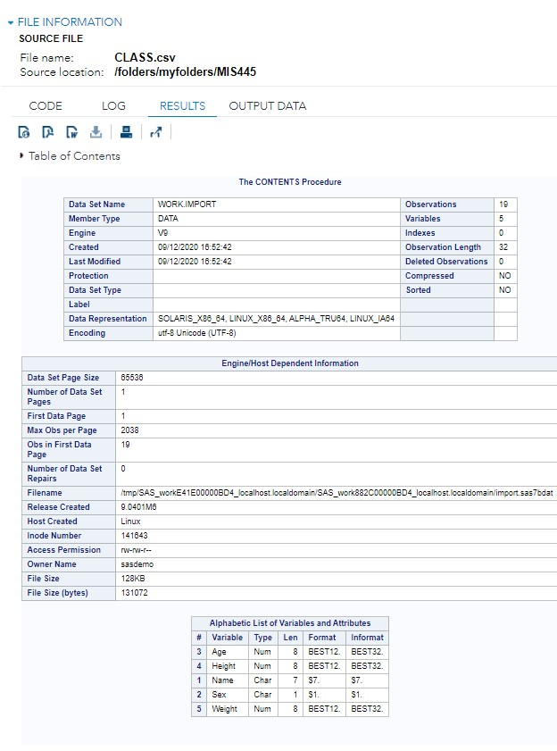

**Answer the Following Questions**

1. How many observations and variables are there in the dataset?

***There are 19 observations and 5 variables in the data set.***

1. What is the file size (in KB)?

***The file size is 128KB.***